

The Concierge Assistant

Installation Instructions for the MARSHA Interface

Step 1 - Copy Importer.exe and EnableMI.exe to the Network Database directory

Step 2 - From Marriott Corporate get the Network directory where the MARSHA export file is downloaded. Also get the file prefix (a.k.a. “Marsha Code”)

For example: Camelback’s import begins with PHXCB, for Desert Ridge: PHXDR

NOTE: The standard profile fields imported include: First Name, Last Name, Address Line 1, Address Line 2, City, State, Postal Code, Country, Do Not Use Postal Mail Flag, Home Phone, Business Phone, and Email Address

Step 3 - Using the Concierge Assistant, add the information in the table below, to your Profile Indicators under the Administration tab.

Preference Type | Sequence
Confirmation Number | 10
Marquis Level | 20
Rewards Number | 30
Fulfillment Flag | 40
First Stay Flag | 50
Reservation Count | 60
Arrival Date | 70
Departure Date | 80
Reservation Date | 90
Number of Nights | 100
Rate Basis | 110
Number of Rooms | 120
Party Size | 130
Experience ID | 140
Market Segment | 150
Rate Code | 160
Special Interest Codes | 170
Special Occasion Codes | 180
Special Request Code | 190
Children's Ages | 200
Email Address | 210
Origin | 220

Step 4 - Launch EnableMI.exe and select whether your Marsha download will be placed on your PMS Server or on a Marriott FTP Site:

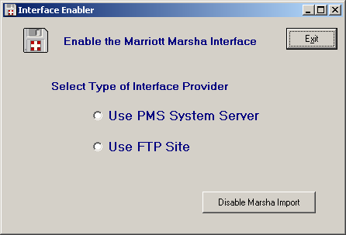
The first step is to select where your Marsha Interface file will be available.

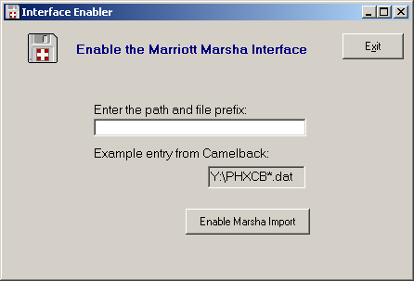
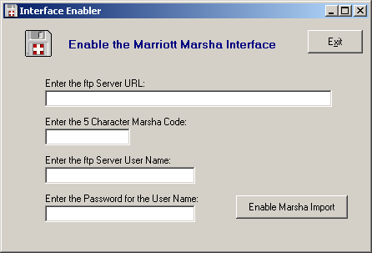
If you select the PMS System Server you will see the following panel:
Here you enter the path to the PMS Server directory and the file prefix of the file (this is the Marsha code for your property)
If you select the FTP Site you will see the following panel:

To implement the FTP solution we need the URL address of the server, the Marsha Code, the Server User Name and Password.

As with the PMS Server panel, you press the Enable Marsha Import button to make the Import button appear on the Profile Search panel.

